STAT 560 HW 1 9/10/14 Barbara Andre

3)

(a) sample mean:

crim nox rm rad medv

3.61 0.55 6.28 9.55 22.53

variance-covariance matrix:

|  |  |  |  |  |  |
| --- | --- | --- | --- | --- | --- |
|  | crim | nox | rm | rad | medv |
| crim | 73.99 | 0.42 | -1.33 | 46.85 | -30.72 |
| nox | 0.42 | 0.01 | -0.02 | 0.62 | -0.46 |
| rm | -1.33 | -0.02 | 0.49 | -1.28 | 4.49 |
| rad | 46.85 | 0.62 | -1.28 | 75.82 | -30.56 |
| medv | -30.72 | -0.46 | 4.49 | -30.56 | 84.59 |

Correlation matrix

|  |  |  |  |  |  |
| --- | --- | --- | --- | --- | --- |
|  | crim | nox | rm | rad | medv |
| crim | 1.00 | 0.42 | -0.22 | 0.63 | -0.39 |
| nox | 0.42 | 1.00 | -0.30 | 0.61 | -0.43 |
| rm | -0.22 | -0.30 | 1.00 | -0.21 | 0.70 |
| rad | 0.63 | 0.61 | -0.21 | 1.00 | -0.38 |
| medv | -0.39 | -0.43 | 0.70 | -0.38 | 1.00 |

c)

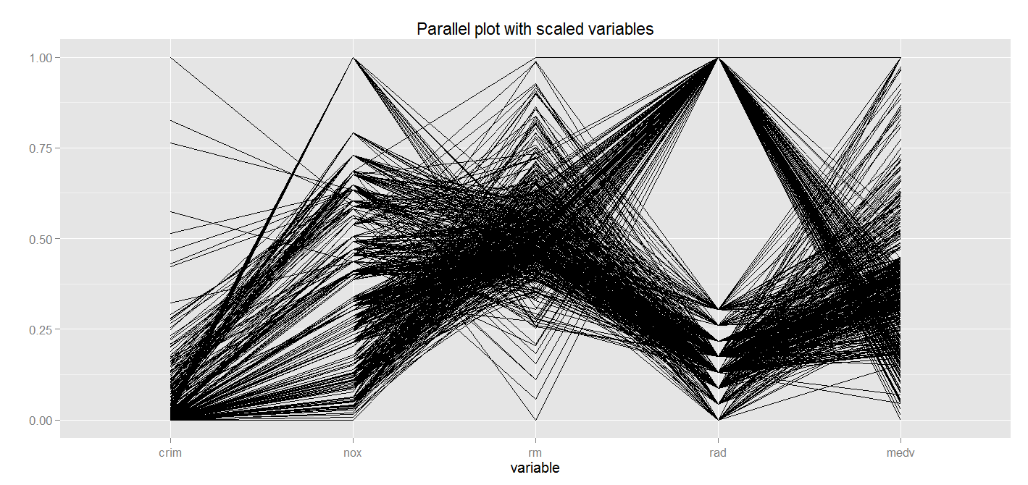

3) c) There appears to be a group defined by accessibility to radial highways which is negatively correlated with the median value of home. Number of rooms appears to be negatively correlated with access to highway and nitric oxide concentrations. I would probably reorder the variables to get a better look at the relationship between crime rates and median value. There appears to be at least one outlier that has large numbers of room, high value and high access to highway. The higher values for crime rates do not appear to follow the same pattern as the lower values.

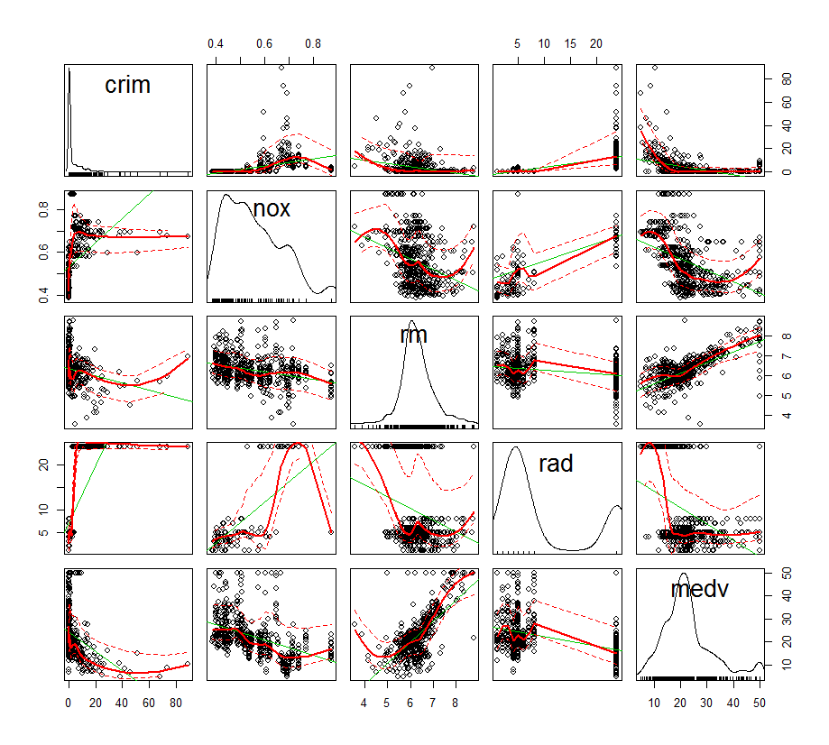

3) d) The relationship between nitric oxide and median value appears to be quadratic. The group of houses with low accessibility to highways has a low crime rate, but those with higher accessibility have a large variability in crime rate. The index of accessibility has two distinct groups.